Exercise 1
Encryption :

$$R_{2} = f_{2}\left(f_{1}\left(r_{0}\right)⊕ l_{0}\right)⊕ r_{0} \\ = f_{2}\left(f_{1}\left(m_{1}\right)⊕ m_{0}\right)⊕ m_{1}$$
$$L_{2} =f_{1}\left(r_{0}\right)⊕ l_{0} \\ = f_{1}\left(m_{1}\right)⊕ m_{0}$$
Decryption
$$L_{2} =f_{1}\left(r_{0}\right)⊕ l_{0}$$
We set $r_{0}=L_{2}, l_{0}=R_{2}$and switch $f_{1}, f_{2}$
$$L_{2} =f_{2}\left(L_{2}\right)⊕ R_{2} \\ =f_{2}\left(f_{1}\left(m_{1}\right)⊕ m_{0} \right)⊕ f_{2}\left(f_{1}\left(m_{1}\right)⊕ m_{0}\right)⊕ m_{1} \\ =m_{1}$$
$$R_{2} = f_{2}\left(f_{1}\left(r_{0}\right)⊕ l_{0}\right)⊕ r_{0}$$
We set $r_{0}=L_{2}, l_{0}=R_{2}$ and switch $f_{1},f_{2}$
$$R_{2} = f_{1}\left(f_{2}\left(L_{2}\right)⊕ R_{2}\right)⊕ L_{2} \\ = f_{1}\left(f_{2}\left(f_{1}\left(r_{0}\right)⊕ l_{0}\right)⊕ f_{2}\left(f_{1}\left(r_{0}\right)⊕ l_{0}\right)⊕ r_{0} \right)⊕ f_{1}\left(r_{0}\right)⊕ l_{0} \\ =f_{1}\left(r_{0}\right)⊕ f_{1}\left(r_{0}\right)⊕ l_{0} \\ =l_{0}$$
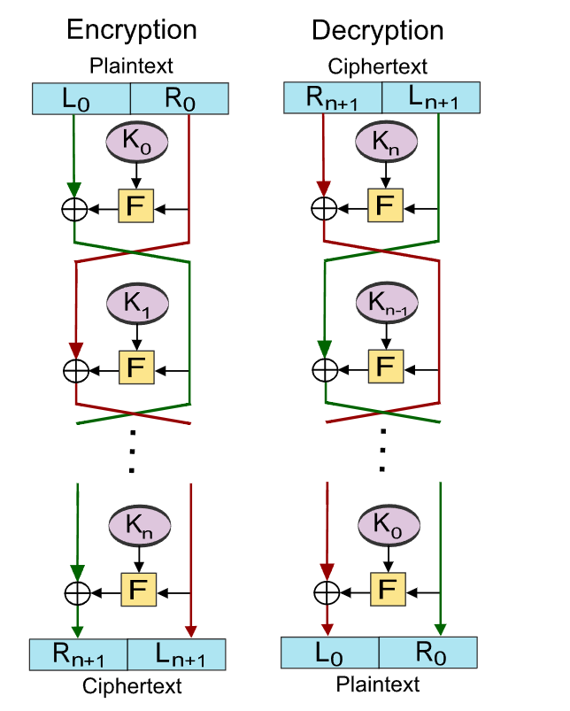

Exercise 2

